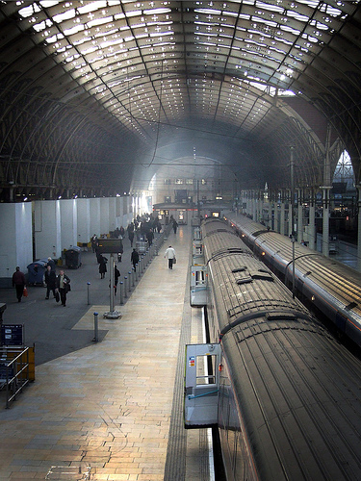
Finding Train Times
Traintimes.org.uk was invented and is hosted by Mathew Somerville. http://www.dracos.co.uk/
using traintimes.org.uk
Image: 'paddington station' www.flickr.com/photos/58109753@N00/98090634

Find train times faster. Find cheaper fares.
Traintimes.org.uk is an online tool that makes it easy to quickly find train times and train fares.

You can search for train times and fares straight from the address bar of your web browser. With no need to fill in forms on a website and wait ages for results – you can find fares right away when in a meeting, making plans or on the phone.

You can bookmark fares and journey details, making it easy to send details of trains to a colleague, or to quickly see the next train for a journey you make often.

You can compare journeys with ease to find the cheapest possible fares.
Getting started

Try these addresses:

- http://www.traintimes.org.uk/leicester/london
For the next trains from Leicester to London
- http://www.traintimes.org.uk/leicester/london/11:00
For trains after 11am from Leicester to London
- http://www.traintimes.org.uk/leicester/london/12:00a
For trains that arrive before 12 noon going from Leicester to London (the ‘a’ on the end of the time means ‘arriving at’)
- http://www.traintimes.org.uk/leicester/london/12:00a/12thNovember
For trains that arrive before 12 noon going from Leicester to London on the 12th November.
- http://www.traintimes.org.uk/leicester/london/12:00a/Next-Tuesday
For trains that arrive before 12 noon going from Leicester to London next Tuesday (you can literally type in things like ‘Monday’ and ‘Next-Thursday’ and traintimes.org.uk will work out when you meant)
- http://www.traintimes.org.uk/leicester/london/12:00a/Next-Tuesday/fares
Add ‘fares’ onto the end to get a list of possible fares.
Tips and tricks
Open a new window each time you enter an address to be able to compare times and fares. You will sometimes find that by splitting a long journey into parts you can get tickets cheaper. For example, a peak time journey from London to Newcastle costs £224, but by getting a ticket to from London to Peterborough and then Peterborough to Newcastle you only pay £144.90. Use traintimes.org.uk to check out other ‘split-ticket-savers’.

